**PART B**

**AIM OF THE PROJECT :** MICRO-PROJECT

**Brief Description :**

* ATM project helps us to access our bank account from any place (ATM center) .
* Its helps us to withdraw money from our bank account and also to check our bank balance, etc
* The project is fully secured with password/pin to access the account
* The project consist of 5modules .
* The pin modules helps you to keep your account safe.It will not provide you the access to your account till you don’t provide the correct secret pin to the account. It reduces the chances of theft.
* The withdraw modules helps you to remove money from your bank account.
* The deposit module helps you to deposite money in your bank account.
* The check balance module allows you to check the current balance in your account
* With the help of quit module you can exit from your account

**Aim of micro project :**

This micro project aims at:

* By using ‘c’ language application & software can be more easily developed.
* Detail study of each concept of ‘c’ language.
* To make banking system more flexible.
* Reduces time, effort and manual work.
* Making use of algorithm and flowchart for better understanding of atm project

**Course Outcome integrated :**

* Use of flow chart and algorithm to solve problems logically
* Use of control structure use of selection and iterative control structures such as switch case and do while loop

**Actual procedure followed :**

1. **Group Formation:-** PCI is a programming language. The basic aim of micro- project is to accelerate the attainment of the variouse outcome in the course.In the first 2 weeks of December the subject was introduced .The syllabus as well as detail of micro-project was discussed.The group of 5 memebers were formed and the group leaders were selected.The schedule of Plan “A”,”B”& “PRESENTATION” were finalized.The variouse micro-project topics related to subject was discussed our guide gave us the opportunity to select the topic of our choice.
2. **Finalization Of Micro-Project:-** After attending the lectures for 2 weeks.We selected the topic for micro-project.We discussed the topic with our Guide regarding the concept which we are going to apply in the project.We individually tried to explain the basic platformof project.
3. **Planning:-** After finalization of the project we started working on the project.we started the planning phase.We discussed among ourselves regarding the resources such as hardware & software requirements,compiler.In this week we completed ‘PART A PLAN’ of the micro-project which is nothing but a initial description about the project.We submitted it to the guide.
4. **Module Distribution &Analysis Part:-** Once the planning was over regarding resources,etc.We finalized the module which we will be designing.According to members we distributed the module among them.We started the analysis of project.
5. **Design Part :-** In this part we created algorithm & flowchart for our micro-project .By doing this our queries related to project got cleared. With the help of this we were able to explain the guide how our project will actually work.
6. **Implementation :-** In the week we actually started the technical phase .In this phase we technically applied the algorithm & flowchart for each module.The coding for each module was done each member was writing code according to module assighned to them.the testing of code was done to achieve the requirementof project.finally the project was within the schedule time.
7. **Presentation :-** In this week we have to present the micro-project in front of the guide.Each member of group presented their own parts with confidence in front of guide.She asked us variouse queries regarding the topics.We presented the details of each concept of ‘C’ that we used in the project.She asked us to do variouse changes regarding some topics.
8. **Submission:-** This week was submission week.We submitted our project along with ‘Part A & B Plan’ to the guide.We also submitted the hard copies and soft copies of project to the guide

**Actual resources used :**

|  |  |  |  |  |
| --- | --- | --- | --- | --- |
| SR NO | NAME OF RESOURCES USED | SPECIFICATION | QUANTITY | REMARKS |
| 1 | COMPUTER | **PROCESSOR**-AMD  **HARD DISK-**2 TB  **RAM**-16GB  **OPERATING SYSTEM**-WINDOWS 10 PRO | 1  1  1  1 | HARDWARE & SOFTWARE USED |
| 2 | TURBO C | TURBO 4.0 |  | IDE & COMPILER FOR C PROGRAMMING |
| 3 | PROGRAMMING LANGUAGE | C |  | PROGRAMMING LANGUAGE |

**Output of the micro project :**

The output of the project is according to following index :

|  |  |
| --- | --- |
| SR NO | CONTENT |
| 1 | ALGORITHM |
| 2 | FLOWCHART |
| 3 | CODING |
| 4 | CODE OUTPUT |
| 5 | REFERENCES |

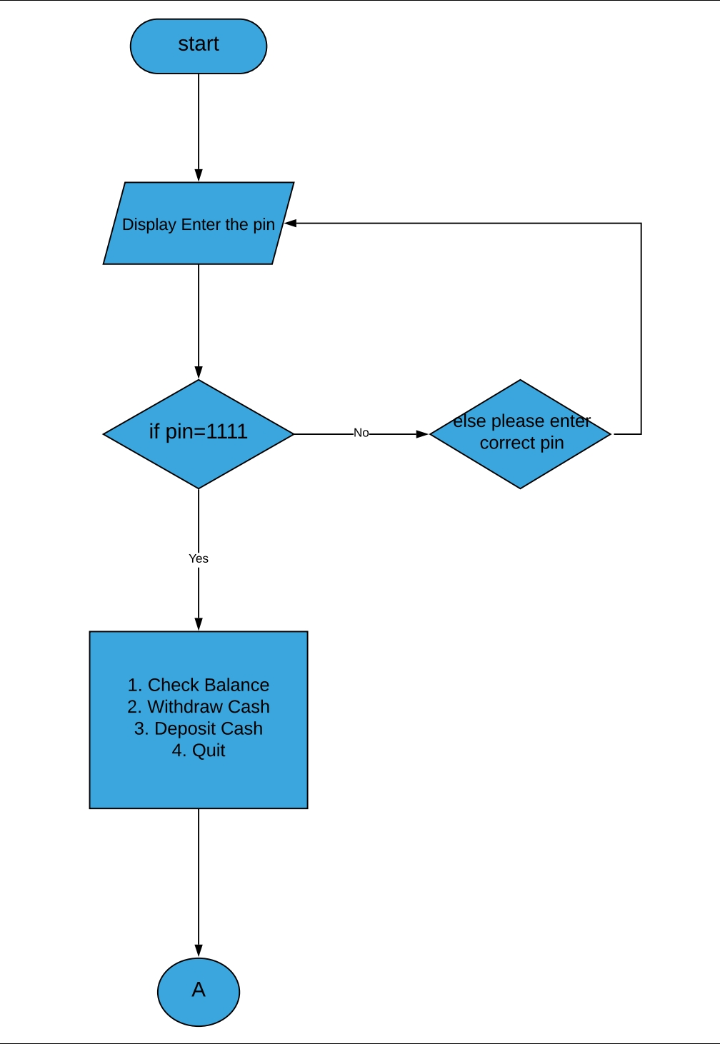FLOW CHART

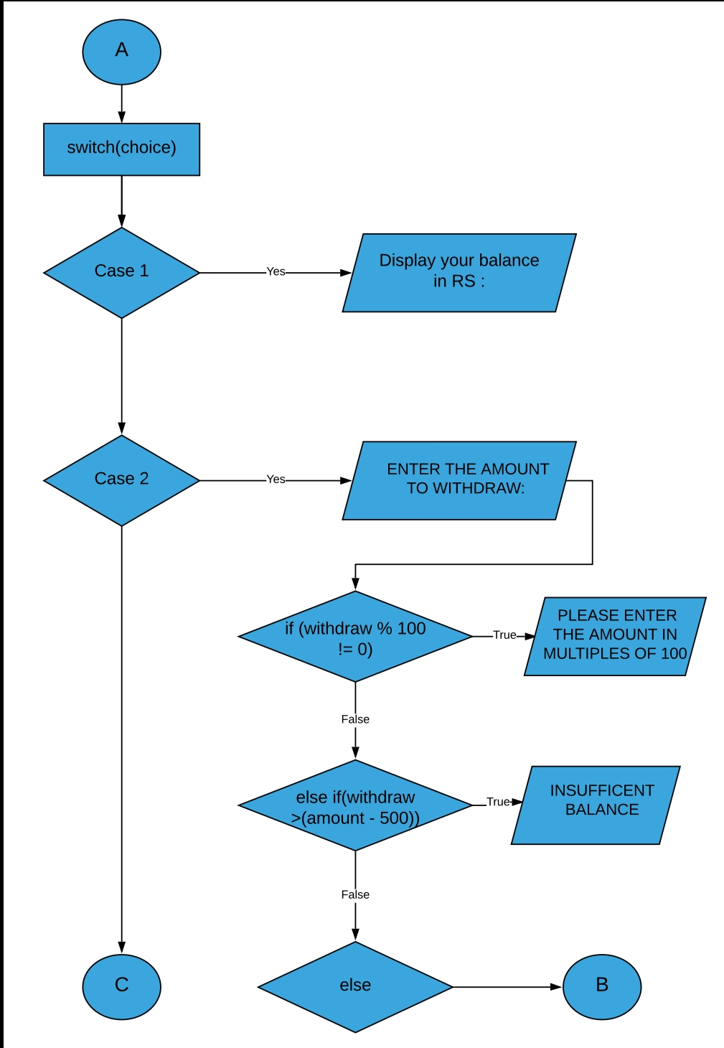

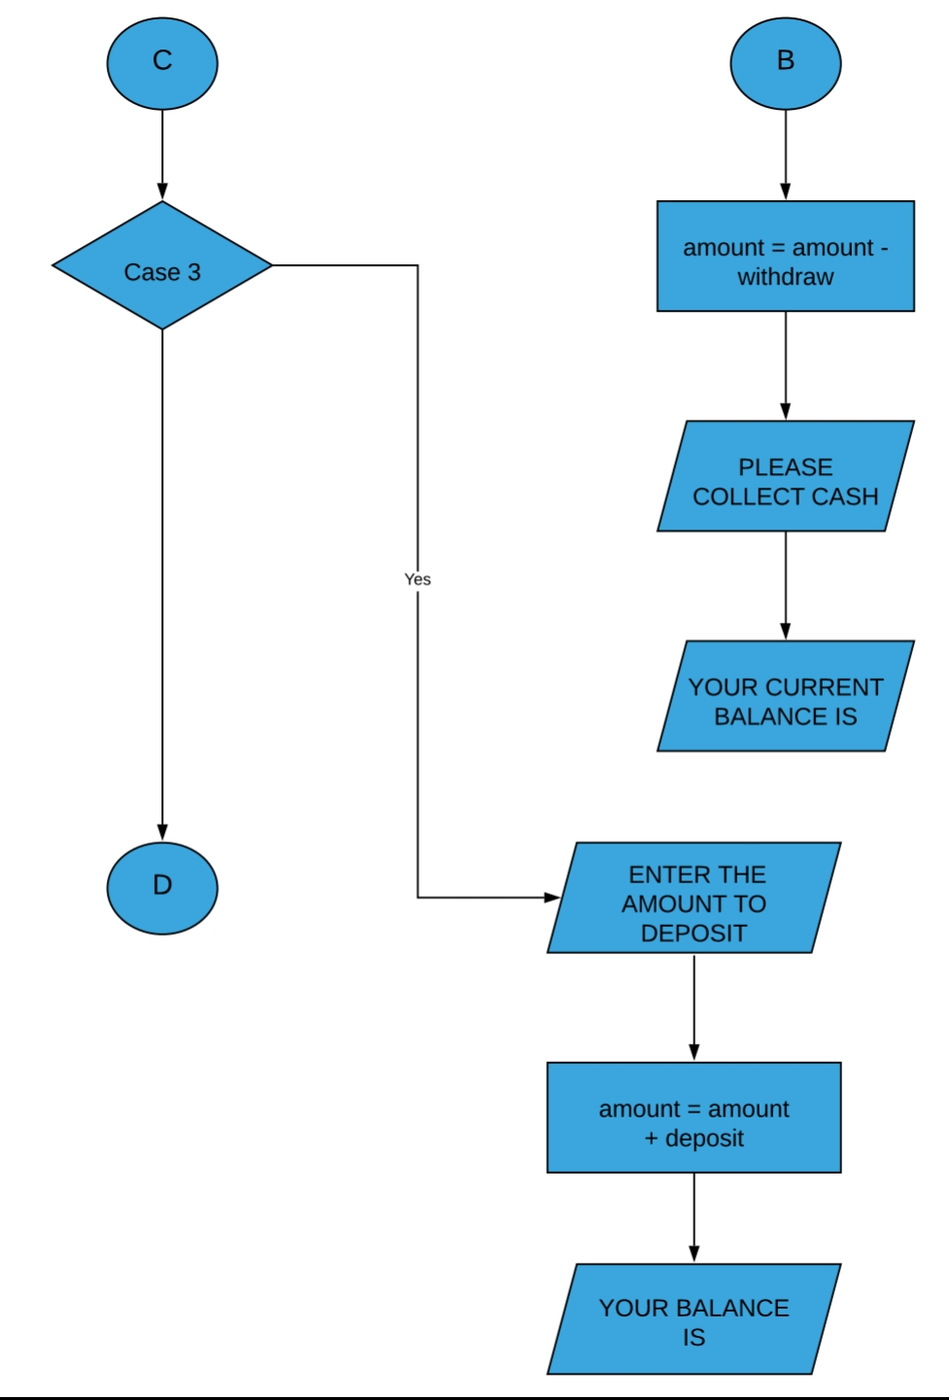

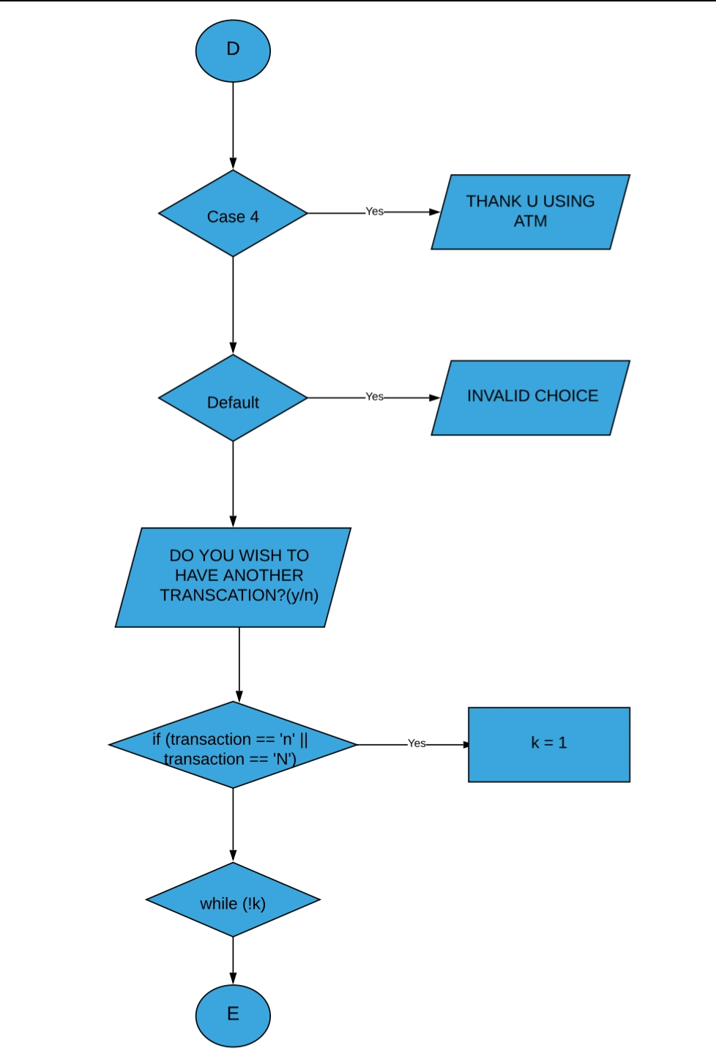

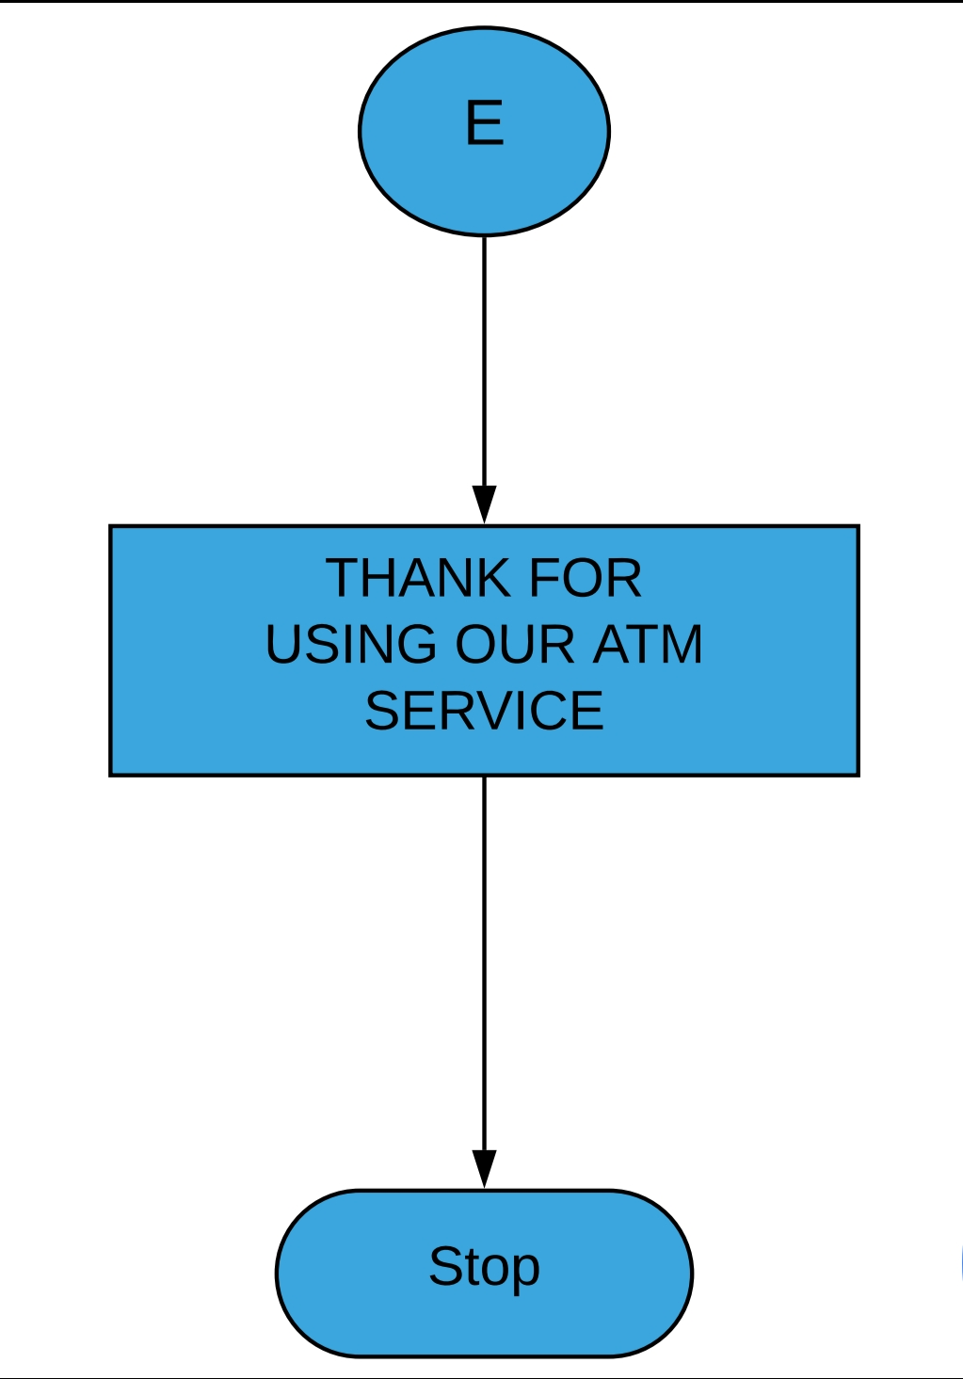

ALGORITHM

**Step 1:** Start

**Step 2:**Declare The Variable Pin, Choice, Withdraw, Deposit, Transaction, Amount

**Step 3:** Input Your Correct Pin Number

**Step 4:** If Entered Wrong Pin

(Display Your Pin Is Not Valid)

Else

(Continue)

**Step 5:** Select Option From Menu Pass The Value To Switch Statement

Case 1: If Choosen Check Your Balance

(Display The Value Of Amount)

Else

(Continue)

Case 2: If Choosen Withdraw Cash

(Display The Balance Before And After Withdrawal)

Else

( Continue)

Case 3 : If Choosen Deposite Cash

( Display The Current Balance After Deposite)

Else

(Continue)

Case 4: If Choosen Quit

( Display Message “ Thank You For Using Atm Service”)

Else

Display Message “ Its An Invalid Option”

**Step 6**: Stop

CODING

#include <stdio.h>

#include <conio.h>

long amount=1000, deposit, withdraw;

int pin, choice, k;

char transaction = 'y';

void main()

{

clrscr();

while (pin != 1111)

{

printf("ENTER YOUR SECRET PIN NUMBER: ");

scanf("%d", &pin);

if(pin != 1111)

printf("PLEASE ENTER VALID PASSWARD\n");

}

do

{

printf("**********WELCOME TO ATM SERVICE**********\n");

printf("1. Check Balance\n");

printf("2. Withdraw Cash\n");

printf("3. Deposit Cash\n");

printf("4. Quit\n");

printf("********************?******************?*\n\n");

printf("Enter your choice: ");

scanf("%d", &choice);

switch (choice)

{

case 1:

printf("\n YOUR BALANCE IN RS : %lu",amount);

break;

case 2:

printf("\n ENTER THE AMOUNT TO WITHDRAW: ");

scanf("%lu",&withdraw);

if (withdraw % 100 != 0)

{

printf("\n PLEASE ENTER THE AMOUNT IN MULTIPLES OF 100");

}

else if(withdraw >(amount - 500))

{

printf("INSUFFICENT BALANCE\n");

}

else

{

amount = amount - withdraw;

printf("\n\n PLEASE COLLECT CASH");

printf("\n YOUR CURRENT BALANCE IS %lu",amount);

}

break;

case 3:

printf("\n ENTER THE AMOUNT TO DEPOSIT ");

scanf("%lu",&deposit);

amount = amount + deposit;

printf("YOUR BALANCE IS %lu",amount);

break;

case 4:

printf("\n THANK U USING ATM");

break;

default:

printf("\n INVALID CHOICE");

}

printf("\n\n\n DO YOU WISH TO HAVE ANOTHER TRANSCATION?(y/n): \n");

fflush(stdin);

scanf("%c",&transaction);

if (transaction == 'n' || transaction == 'N')

k = 1;

}

while (!k);

printf("\n\n THANK FOR USING OUT ATM SERVICE");

getch();

}

OUTPUT

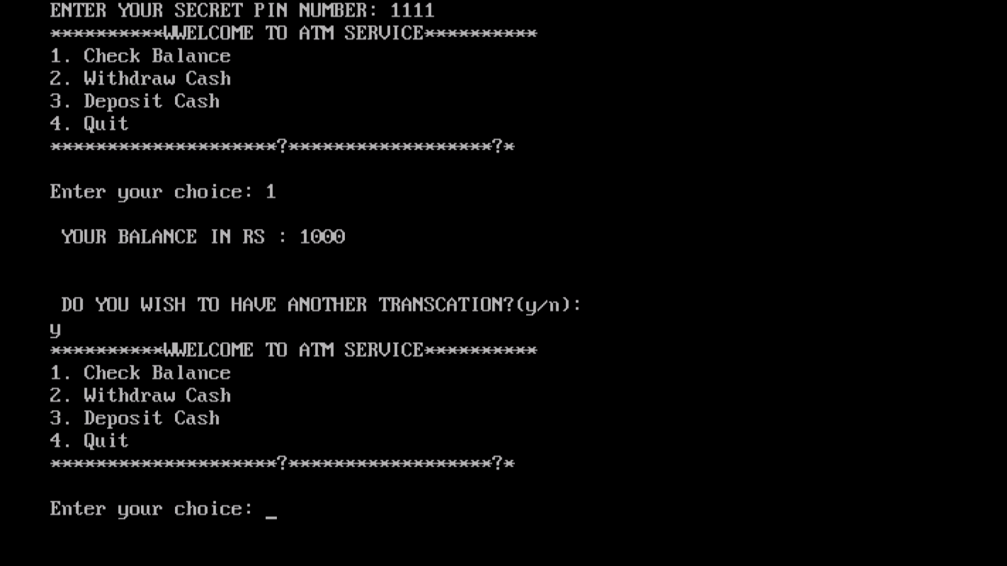

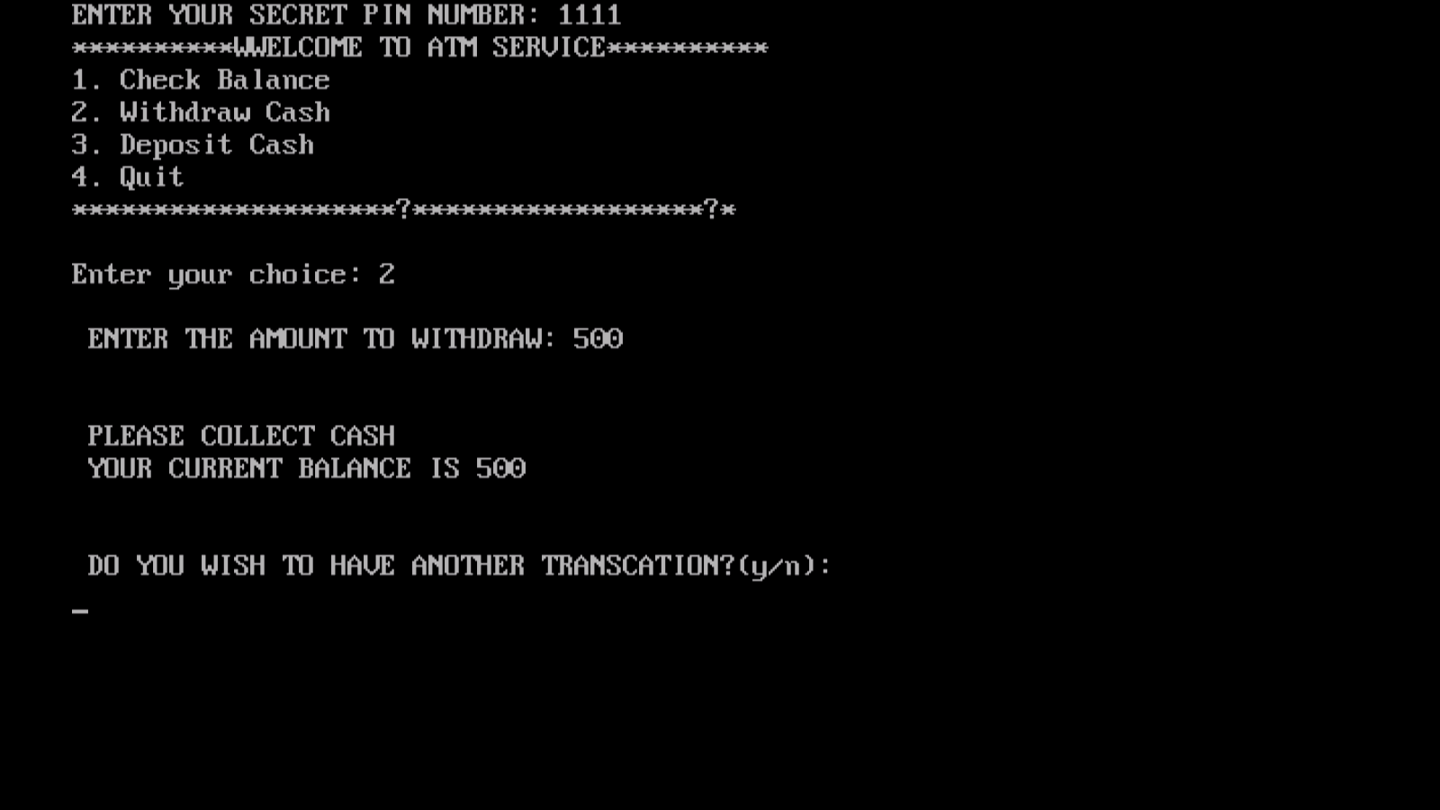

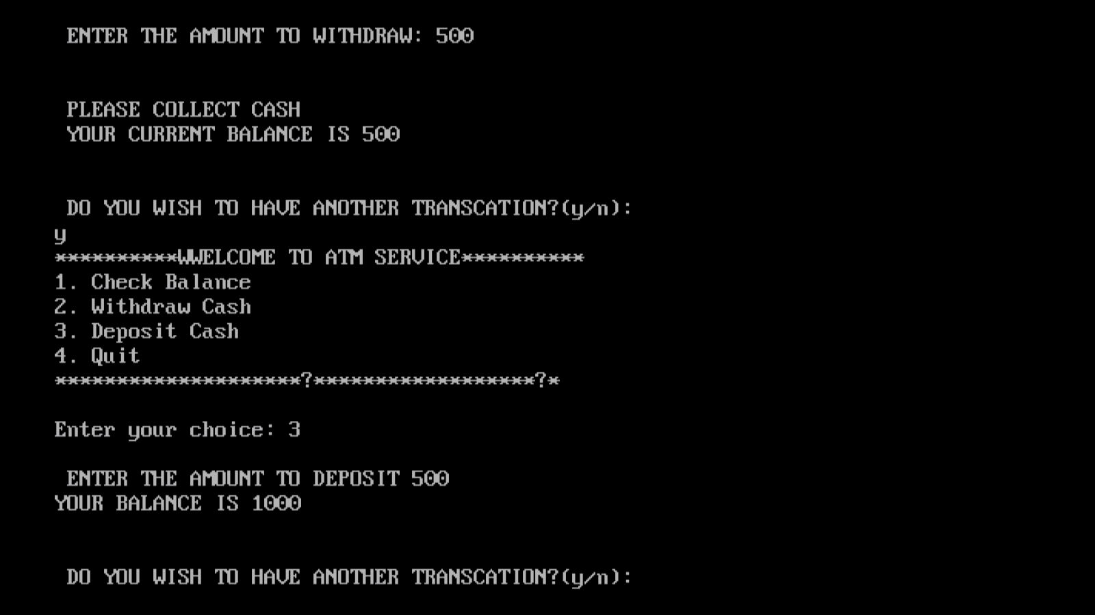

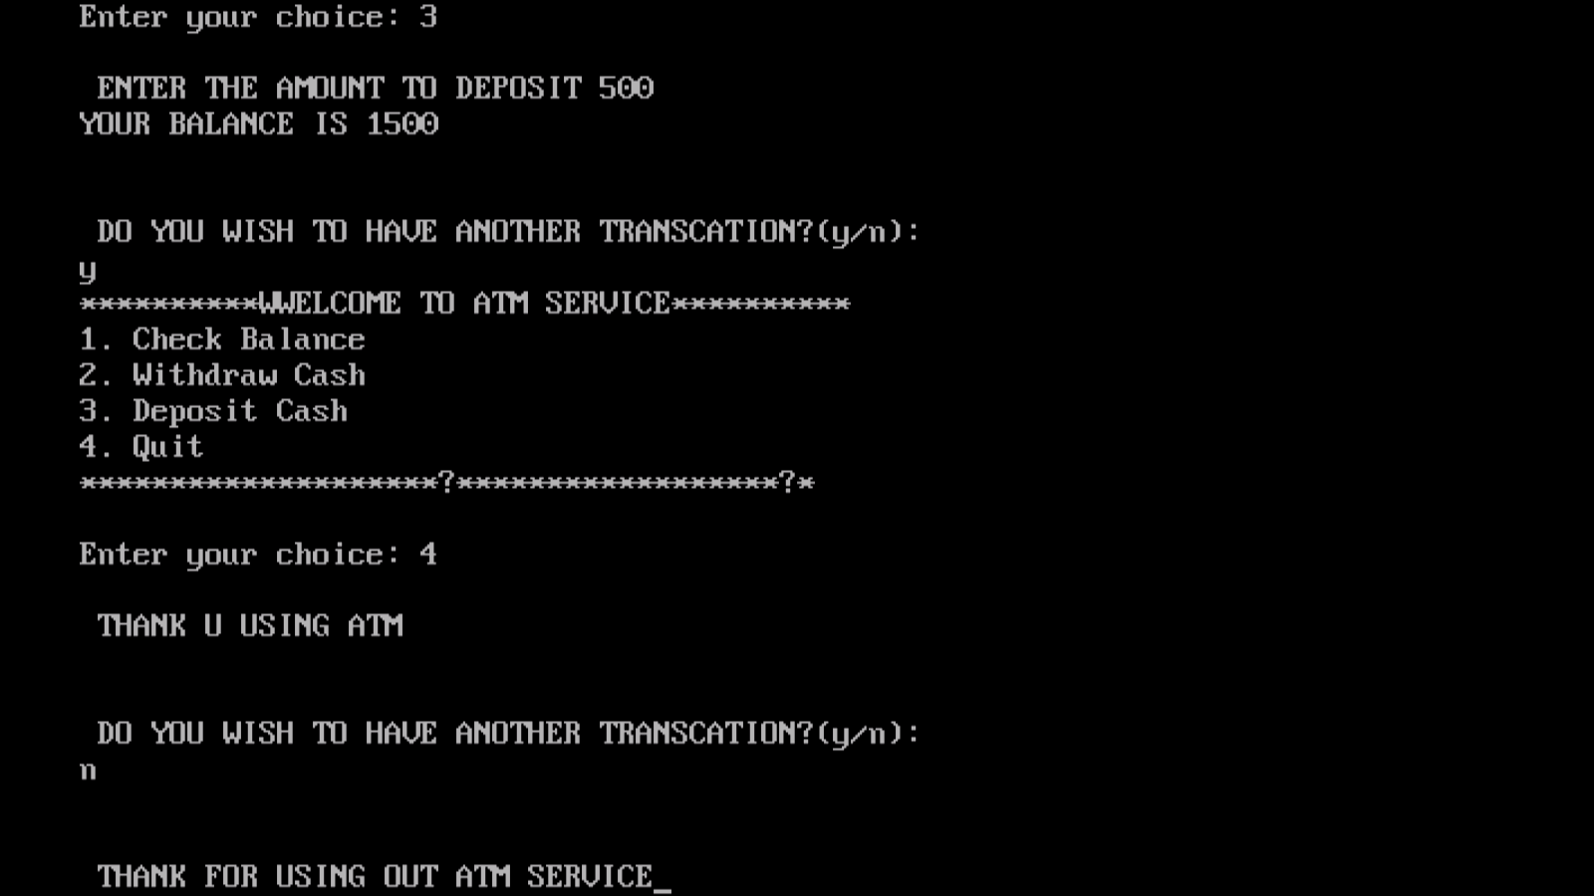

REFERENCES

We do have used a few references during the process of building our project. The references used are from Websites, Books etc.

The references used are:

WEBSITES:

1: www.programiz.com.

2: www.tutorialspoint.com.

3: www.quora.com.

REFERENCE BOOKS:

1: C the complete refrence

2: Head first c

**Skill developed/learning out of this micro project :**

* Since we worked in a group,We developed the skill of ‘TEAMWORK’ in us
* We came to know how and when to use some of the important concept of “c” language.
* We attained the satisfied level of programming